9.30 to 11.30

11.30 to 12.30 django

**Function calling another Function**

f1() calling f2()

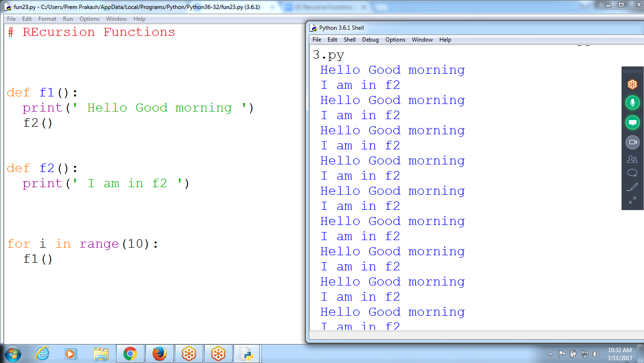

def f1():

print(' Hello Good morning ')

f2()

def f2():

print(' I am in f2 ')

for i in range(10):

f1()

**Cycle function**

Function f1(), calling another function f2()

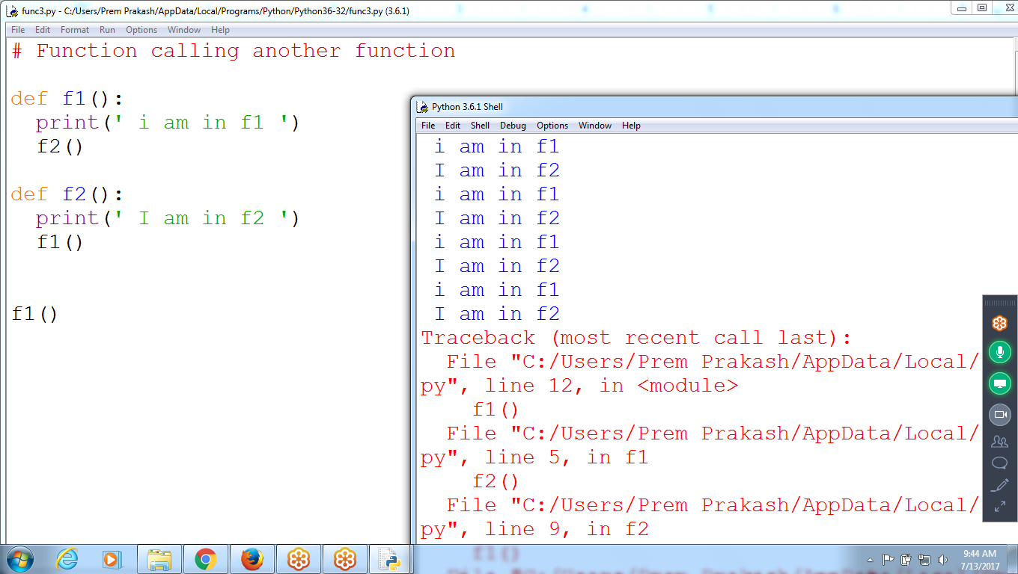

**Recursive Functions :** Function Calling Itself

Ex: Function calling One Time

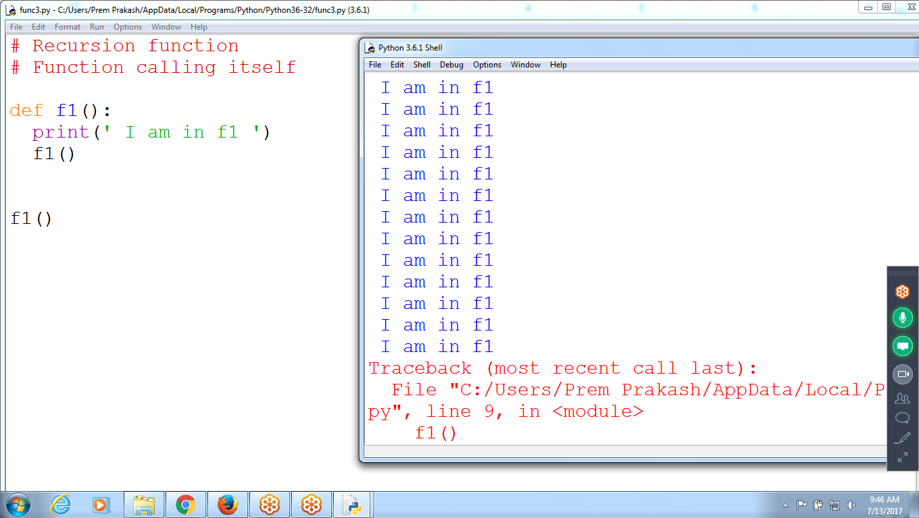

Function Calling Itself

f1() calling f1() itself

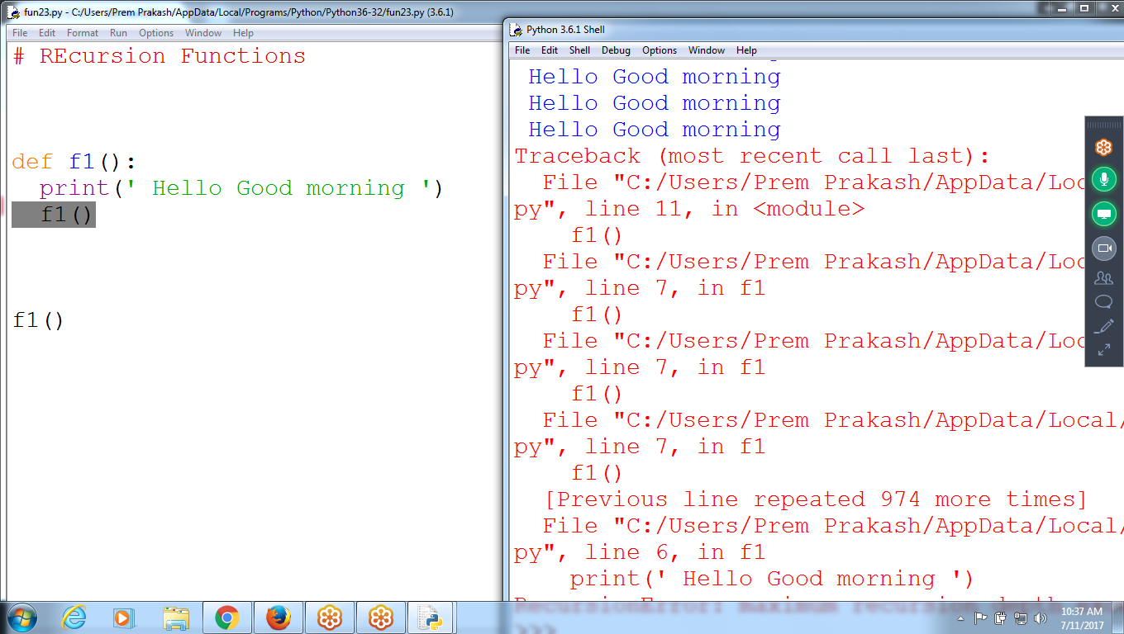

Calling Function

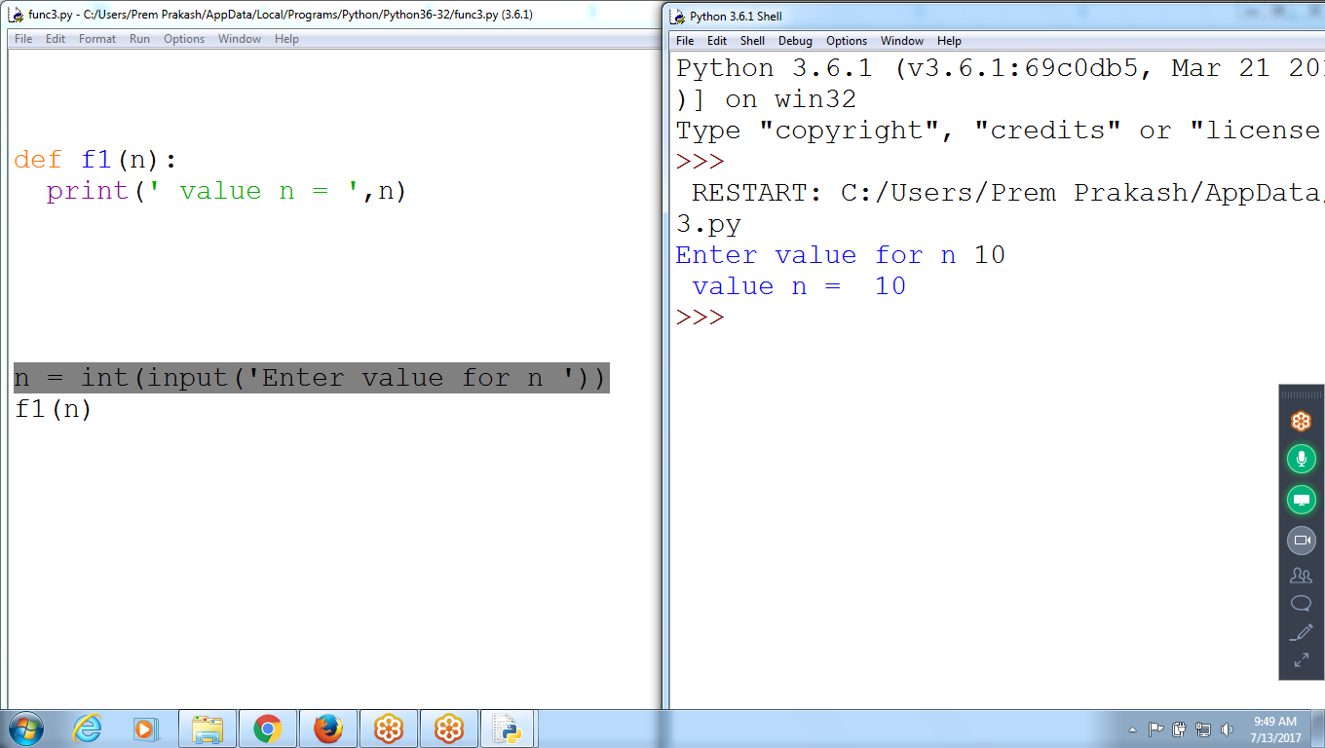

Ex: Recursive Function

Where n value decrement by 1

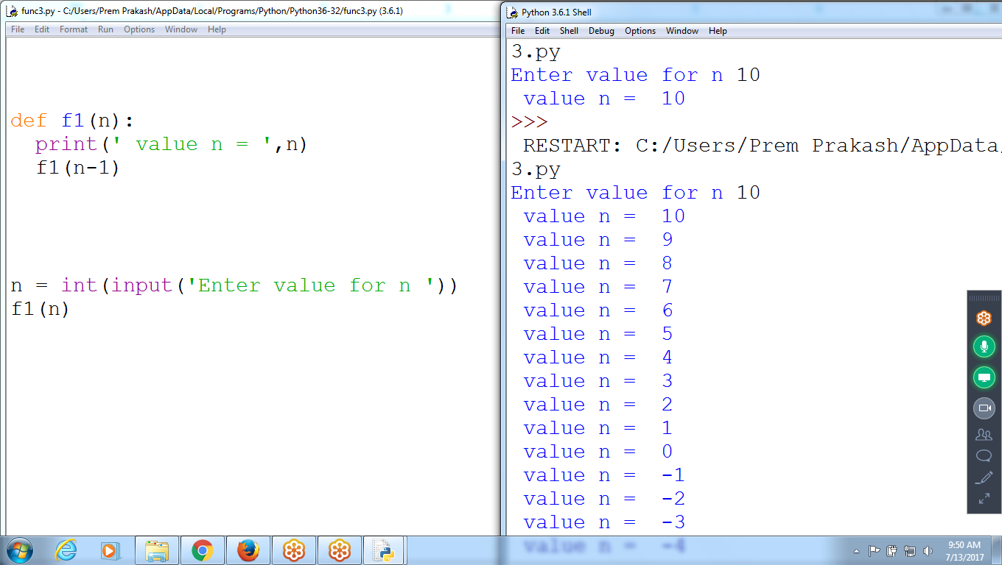

def f1(n):

print(' value n = ',n)

f1(n-1)

n = int(input('Enter value for n '))

f1(n)

Recursive function, Return value at particular situation

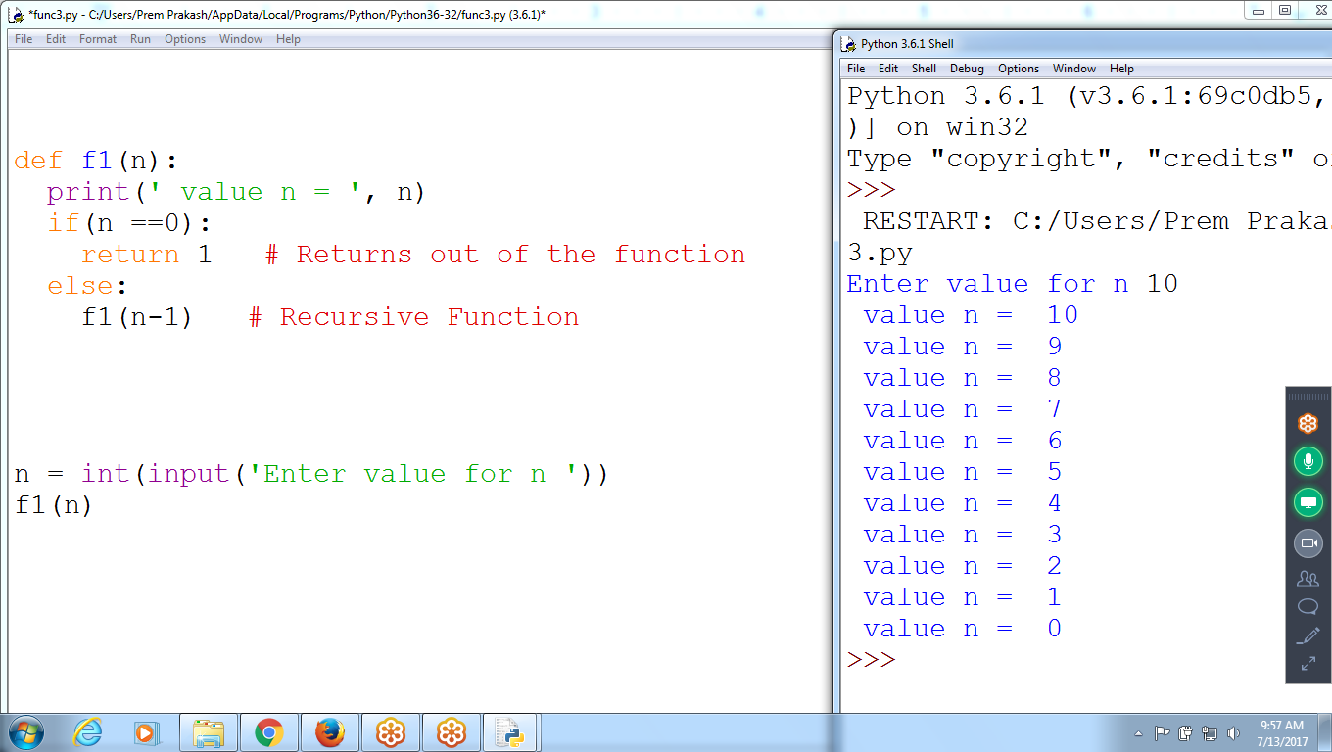

def f1(n):

print(' value n = ', n)

if(n ==0):

return 1 # Returns out of the function

else:

f1(n-1) # Recursive Function

n = int(input('Enter value for n '))

f1(n)

Using Recursion Find Factorial of Given number

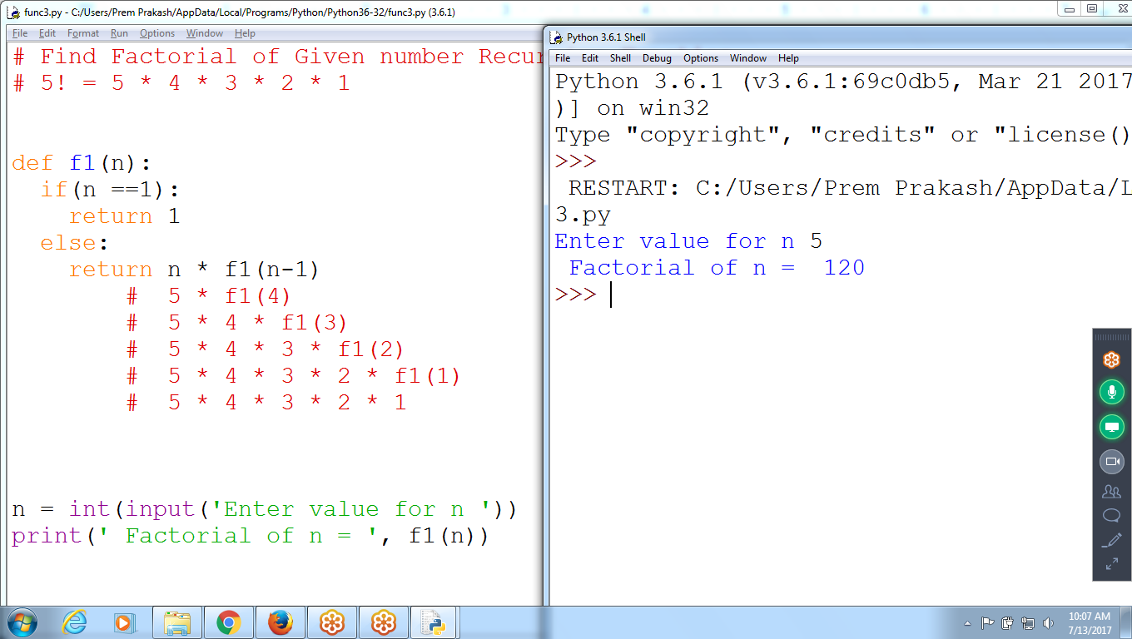

# Find Factorial of Given number Recursive Function

# 5! = 5 * 4 * 3 * 2 * 1

def f1(n):

if(n ==1):

return 1

else:

return n * f1(n-1)

# 5 * f1(4)

# 5 * 4 * f1(3)

# 5 * 4 * 3 * f1(2)

# 5 * 4 * 3 * 2 * f1(1)

# 5 * 4 * 3 * 2 * 1

n = int(input('Enter value for n '))

print(' Factorial of n = ', f1(n))

Factorial of given number using RECURSION

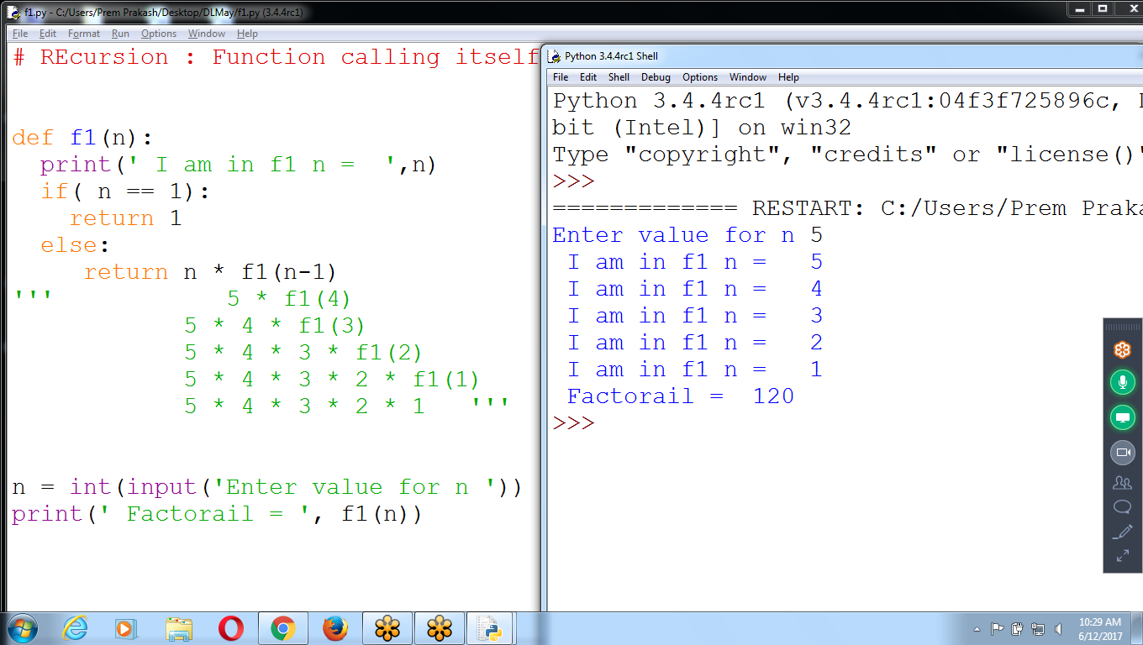

# REcursion : Function calling itself

def f1(n):

print(' I am in f1 n = ',n)

if( n == 1):

return 1

else:

return n * f1(n-1)

''' 5 * f1(4)

5 * 4 * f1(3)

5 * 4 * 3 * f1(2)

5 * 4 * 3 * 2 * f1(1)

5 * 4 * 3 * 2 * 1 '''

n = int(input('Enter value for n '))

print(' Factorial = ', f1(n))

# Without Recursion

# Function to Find Power values

# 2 power 0 = 1

# 2 power 5 = 32

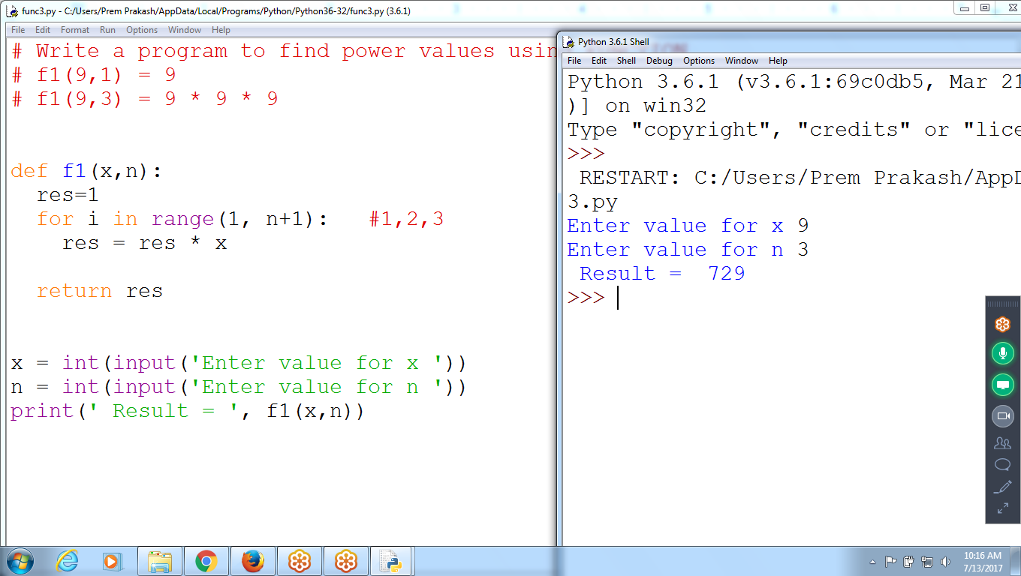

# Write a program to find power values using FUNCTION

# f1(9,1) = 9

# f1(9,3) = 9 * 9 * 9

def f1(x,n):

res=1

for i in range(1, n+1): #1,2,3

res = res * x

return res

x = int(input('Enter value for x '))

n = int(input('Enter value for n '))

print(' Result = ', f1(x,n))

# Function to Find Power values using RECURSIVE Functions

# 2 power 0 = 1

# 2 power 5 = 32

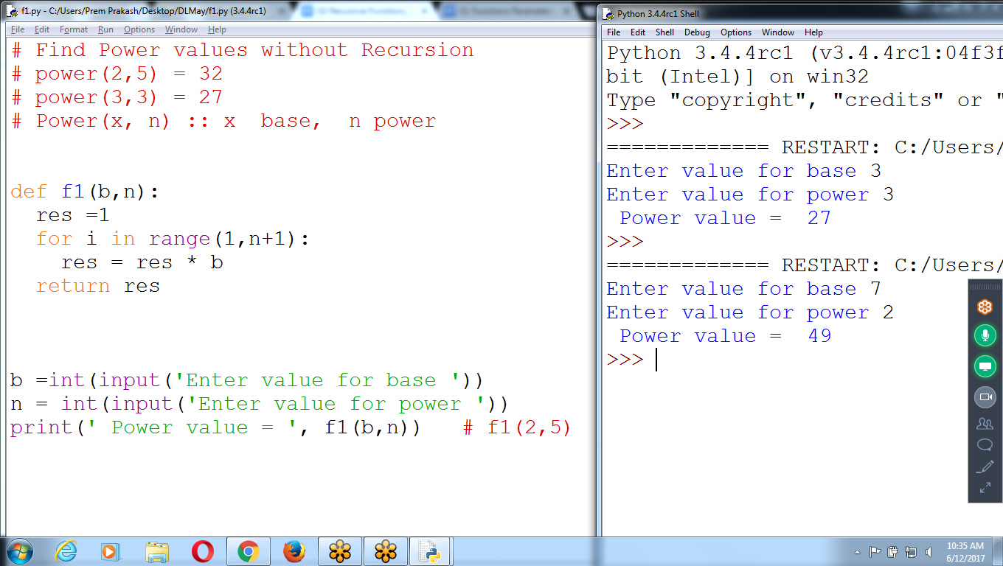

# Find Power values without Recursion

# power(2,5) = 32

# power(3,3) = 27

# Power(x, n) :: x base, n power

def f1(b,n):

res =1

for i in range(1,n+1):

res = res * b

return res

b =int(input('Enter value for base '))

n = int(input('Enter value for power '))

print(' Power value = ', f1(b,n)) # f1(2,5)

Using Recursion find Power values

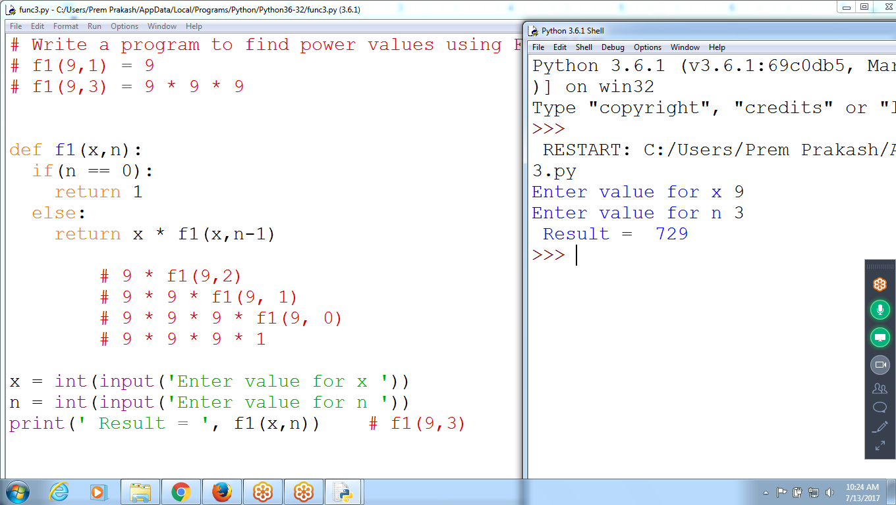

# Write a program to find power values using FUNCTION

# f1(9,1) = 9

# f1(9,3) = 9 * 9 * 9

def f1(x,n):

if(n == 0):

return 1

else:

return x * f1(x,n-1)

# 9 * f1(9,2)

# 9 * 9 * f1(9, 1)

# 9 * 9 * 9 * f1(9, 0)

# 9 * 9 * 9 * 1

x = int(input('Enter value for x '))

n = int(input('Enter value for n '))

print(' Result = ', f1(x,n)) # f1(9,3)

Examples:

Games like :: tic tac, Chess

1 0 1

1 1 1

0 0 1